**Course One**

# Foundations of Data Science



# Instructions

Use this PACE strategy document to record decisions and reflections as you work through this end-of-course project. You can use this document as a guide to consider your responses and reflections at different stages of the data analytical process. Additionally, the PACE strategy documents can be used as a resource when working on future projects.

# Course Project Recap

Regardless of which track you have chosen to complete, your goals for this project are:

* Complete the PACE Strategy Document to plan your project while considering your audience members, teammates, key milestones, and overall project goal.
* Create a project proposal for the data team.

# Relevant Interview Questions

Completing this end-of-course project will empower you to respond to the following interview topics:

* As a new member of a data analytics team, what steps could you take to get 'up to speed' with a current project? What steps would you take? Who would you like to meet with?
* How would you plan an analytics project?
* What steps would you take to translate a business question to an analytical solution?
* Why is actively managing data an important part of a data analytics team's responsibilities?
* What are some considerations you might need to be mindful of when reporting results?

**Reference Guide**

This project has three tasks; the following visual identifies how the stages of PACE are incorporated across those tasks.

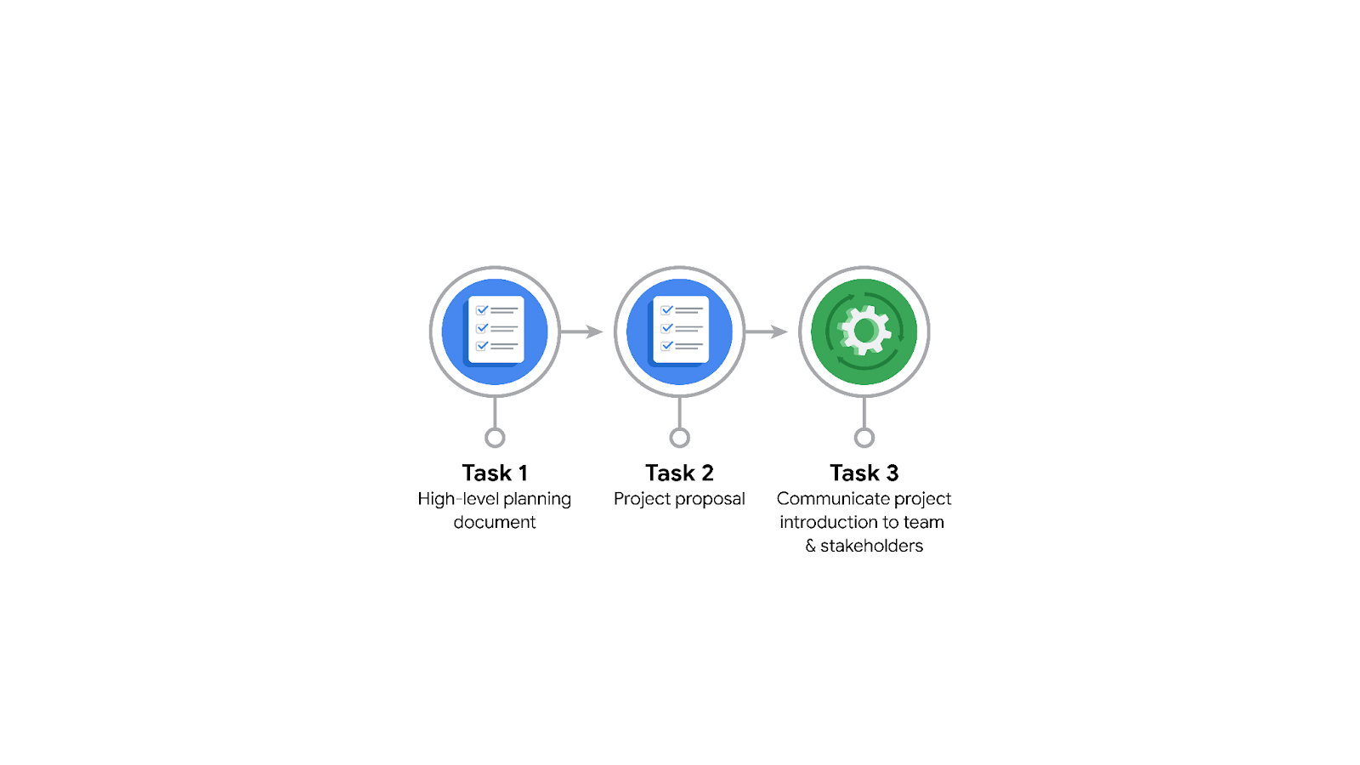

**Data Project Questions & Considerations**

**PACE: Plan Stage**

* Who is your audience for this project?

The primary audience is the Waze leadership team and data team members.

* What are you trying to solve or accomplish? And, what do you anticipate the impact of this work will be on the larger needs of the client?

The goal is to develop a machine learning model to predict user churn. This model will help Waze prevent user churn, improve user retention, and grow the business.

* What questions need to be asked or answered?

Who are the users most likely to churn?

Why do users churn?

When do users churn?

What factors contribute to user churn?

How can Waze improve user retention based on the model's insights?

* What resources are required to complete this project?

Historical user data

Tools for data analysis (e.g., Python, Jupyter Notebook)

Machine learning libraries (e.g., scikit-learn)

Visualization tools (e.g., Tableau)

* What are the deliverables that will need to be created over the course of this project?

Project proposal

Data exploration and cleaning report

Hypothesis testing results

Descriptive statistics summary

Machine learning model

Model evaluation report

Final presentation to stakeholders

## **THE PACE WORKFLOW**

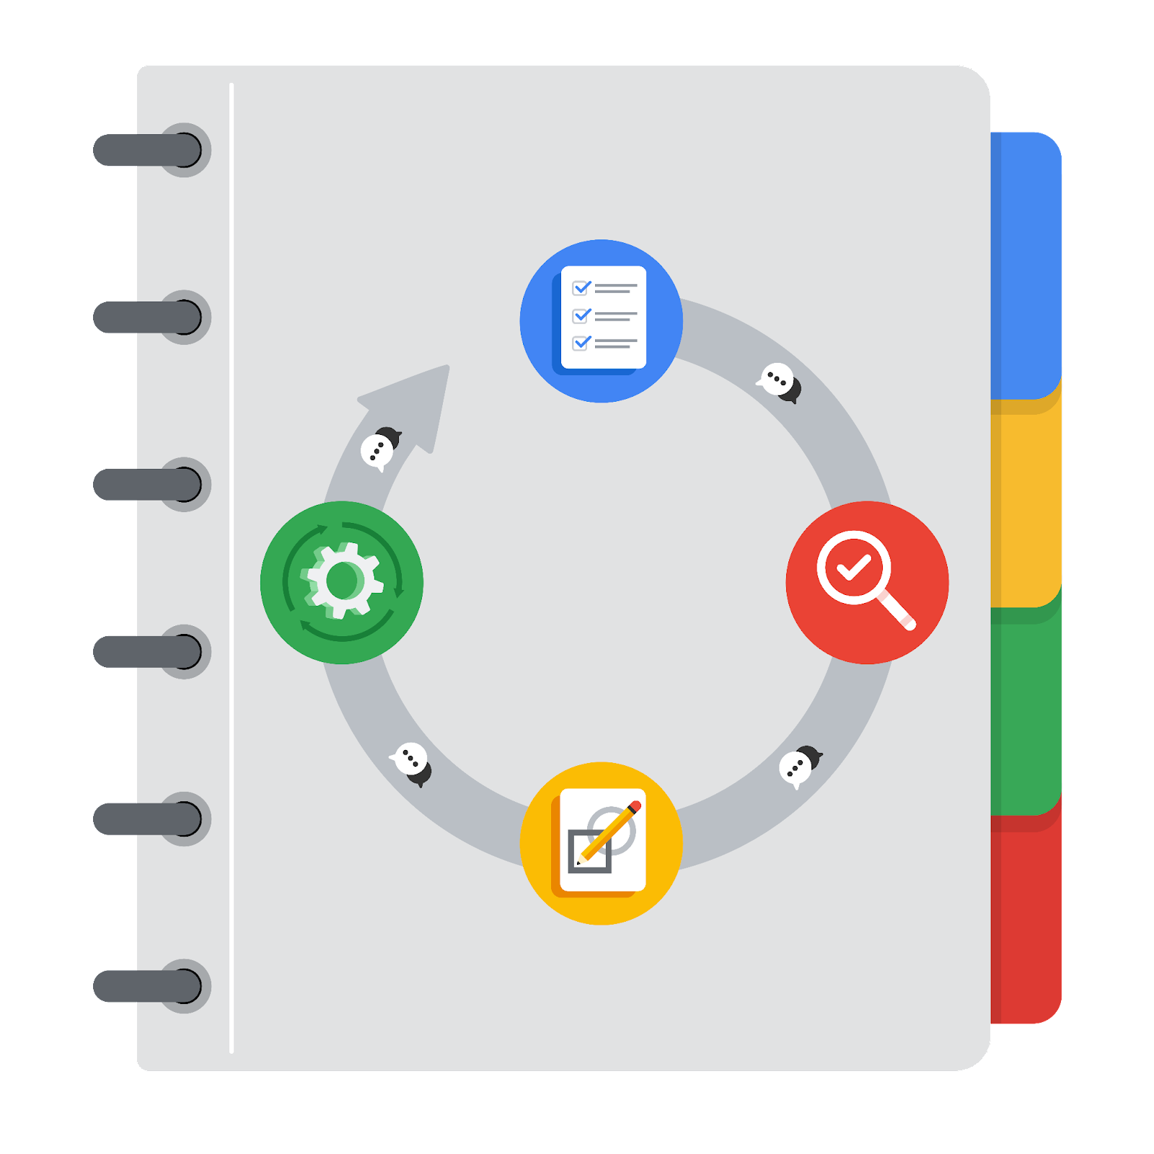

**[Alt-text: The PACE Workflow with the four stages in a circle: plan, analyze, construct, and execute.]**

You have been asked to demonstrate for the company's data team how you would use the PACE workflow to organize and classify tasks for the upcoming project. Select a PACE stage from the dropdown buttons. A few tasks involve more than one stage of the PACE workflow. Additionally, not every workplace scenario will require every task. Refer back to the Course 1 end-of-course portfolio project overview reading if you need more information about the tasks within the project.

### 

### **Project tasks**

Following are a group of tasks your company’s data team has determined need to be completed within this project. The data analysis manager has asked you to organize these tasks in preparation for the project proposal document. First, identify which stage of the PACE workflow each task would best fit under using the drop down menu. Next, give an explanation of why you selected the stage for each task. Review the following readings to help guide your selections and explanation: [The PACE stages](https://www.coursera.org/learn/foundations-of-data-science/supplement/4OtHr/the-pace-stages) and [Communicate objectives with a project proposal](https://www.coursera.org/learn/foundations-of-data-science/supplement/79Ysh/communicate-objectives-with-a-project-proposal). You will later reorder these tasks within a project proposal.

1. **Evaluating the model:** Construct

Why did you select this stage for this task?

Model evaluation is typically performed after the model is built, during the construction phase to ensure it meets the desired performance metrics.

BUT evaluating the model might be seen as part of the planning stage if you consider evaluation criteria and metrics early in the project to ensure alignment with project goals.

1. **Conduct hypothesis testing:** Analyze **and** Construct

Why did you select these stages for this task?

Hypothesis testing requires analyzing the data and constructing the tests to validate hypotheses.

1. **Begin exploring the data:** Plan

Why did you select this stage for this task?

Early exploration can help plan the project by identifying potential challenges and opportunities.

1. **Data exploration and cleaning:** Analyze **and** Construct

Why did you select these stages for this task?

Complete data exploration is part of the analysis, and cleaning can be considered both an analysis and constructive task as it involves transforming the data.

1. **Establish structure for project workflow (PACE):** Plan

Why did you select this stage for this task?

Structuring the project workflow is part of the planning phase.

1. **Communicate final insights with stakeholders:** Execute

Why did you select this stage for this task?

Communicating insights is the execution stage where the results are shared.

1. **Compute descriptive statistics:** Analyze

Why did you select this stage for this task?

Calculating descriptive statistics is part of analyzing the data, is where you see the data and know what to do with it.

1. **Visualization building:** Analyze **and** Construct

Why did you select these stages for this task?

Building visualizations involves analyzing the data and constructing the visuals.

1. **Write a project proposal:** Plan

Why did you select this stage for this task?

Creating a project proposal is part of the planning phase. To write is to plan.

1. **Build a regression model:** Analyze **and** Construct

Why did you select this stage for this task?

Building a regression model involves analyzing the data and constructing the model as so Compute.

1. **Compile summary information about the data:** Plan

Why did you select this stage for this task?

Summarizing data could guide the project planning by providing an overview.

1. **Build machine learning model:** Construct

Why did you select this stage for this task?

Constructing the machine learning model is a core part of the construction stage.